Task 2

**For the database you’ll have to use PostgreSQL. This cluster must be highly available**

**in case one zone goes down and even in case a whole region goes down due to a natural**

**disaster (tip: if you have proper automation backup and recovery in failover region could**

**be an option) - Using managed solution is not allowed**

1. Created 3 EC2 Instance
   1. (2 in one AZ (Mumbai) & 1 at region level (North California NA)

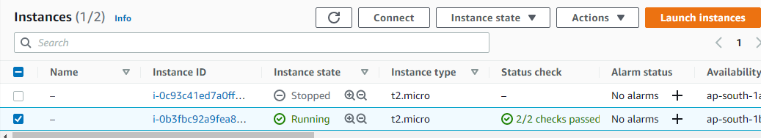

b. at region level (North California NA)

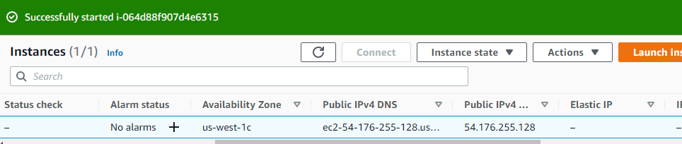

Postgres Replication is enabled with Availability Zone Instance and Region Instance

[postgres@ip-172-31-4-230 bin]$ ./repmgr daemon status

ID | Name | Role | Status | Upstream | repmgrd | PID | Paused? | Upstream last seen

----+-----------+---------+-----------+-----------+-------------+-----+---------+--------------------

1 | postgresA | primary | * running | | not running | n/a | n/a | n/a

2 | postgresB | standby | running | postgresA | not running | n/a | n/a | n/a

3 | postgresC | standby | running | postgresA | not running | n/a | n/a | n/a

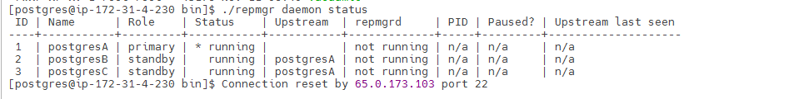

Since there replication enabled at region level failover will not be problem but backup has been enabled through cron which stores Data in S3 bucket both logical & physical which will get delete after certain period.

0 7 * * * /var/lib/pgsql/12/data/scripts/postgres_logical_backup.sh >> /var/lib/pgsql/12/data/scripts/logs/backup_logical_log 2>&1

0 6 * * * /var/lib/pgsql/12/data/scripts/postgres_base_backup.sh > /var/lib/pgsql/12/data/scripts/logs/backup_base.log 2>&1

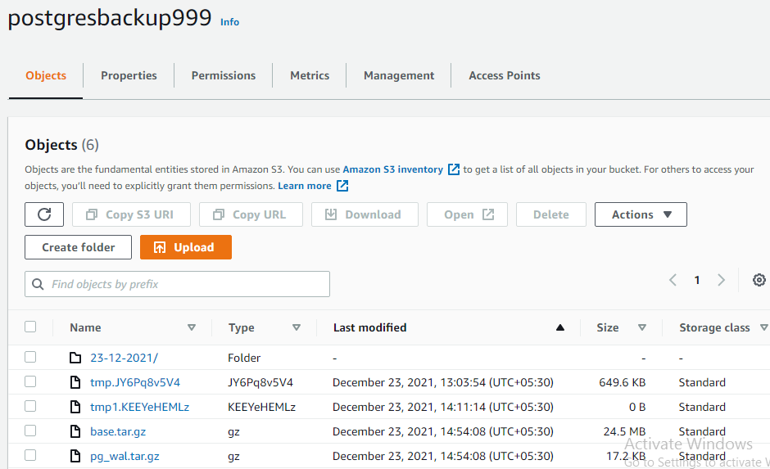

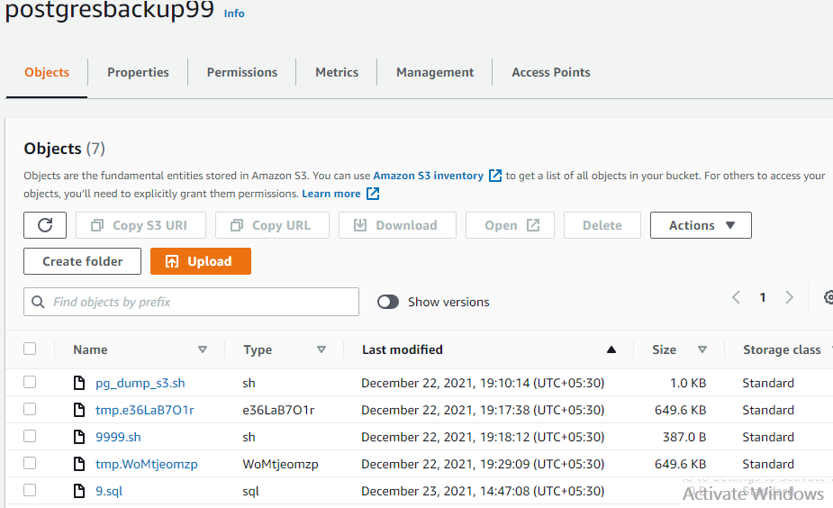

** Had to configure Replication through Public Ip as interconnect between private ip among 2 region wasn’t possible without support from additional tool from marketplace.

I have used DVD rental as default database